**Yuav ua li cas teev cov duab los qhia rau khaws**

Daim ntawv ceeb toom no tau muab tso rau ntawm cov Kev tag nrho cov tsheb thauj khoom hauv nroog. Qhov no **Tsis txhais tau** tias peb muaj teeb meem nrog cov ntsiab lus ntawm lub tsheb thauj khoom.

**Yuav ua li cas kom teev cov duab los qhia kom yog:**

• **Tshem tag nrho cov khoom ntim tawm thiab cov thawv pav.**

• Cov thawv uas tsis haum rau koj lub tawb thim yuav muab tso rau ib sab ntawm koj lub taub ua khoom siv sab hauv ib lub thawv loj los sis ntim cov hlua sib txuas ua ke nrog txoj hlua los sis muab kauv.

• Tsis txhob ntim cov thawv uas siv xaim los sis xev.

• Khaws cov thawv kom tsawg dua 3 'x 3' thiab tsawg dua 40 phaus.

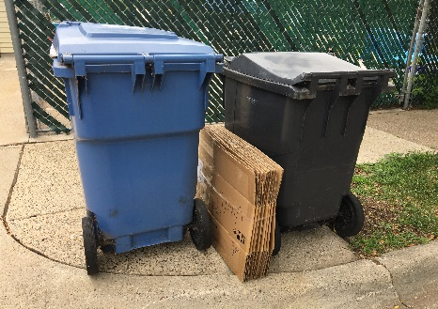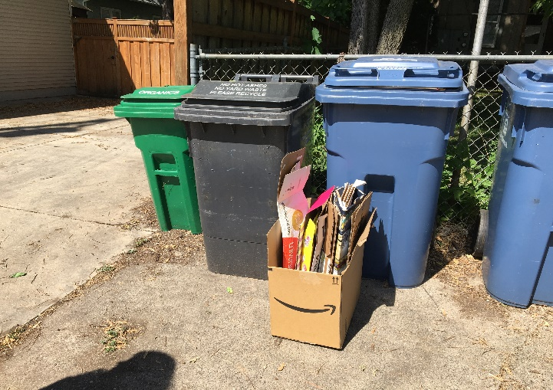

**Teev cov duab los qhia cia yuav tsum tsis zoo li:**

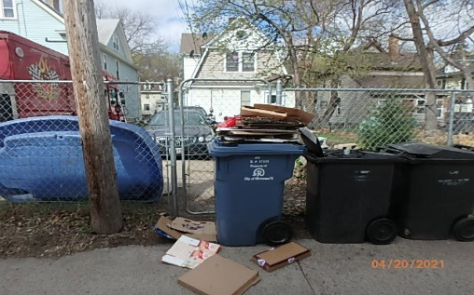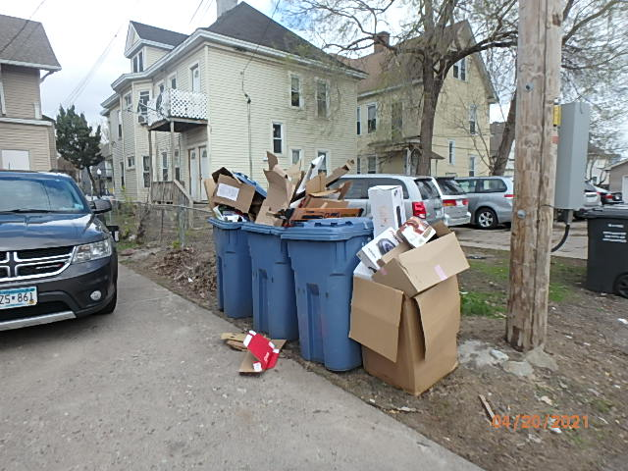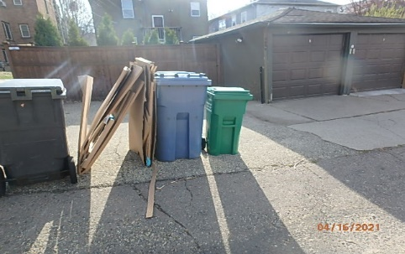

 Kev ua duab qhia uas tsis raug npaj yuav tsis ntim. Ua tsaug rau koj uas mloog.

Yog xav paub ntxiv hu rau Khoom Pov Tseg thiab Lub Cav Thau Khoom ntawm 612-673-2917,

Xas email rau peb ntawm [SWRcustomer@minneapolismn.gov](mailto:SWRcustomer@minneapolismn.gov)

Los sis mus saib [**minneapolismn.gov/recycling**](https://www.minneapolismn.gov/resident-services/garbage-recycling-cleanup/recycling/)

Cov neeg tsis hnov lus tuaj yeem siv cov kev hu xov tooj rau 311 at 612-673-3000

Cov siv TTY hu rau 612-263-6850